**Semester 1 (Unit 3) Examination, 2020**

**Question/Answer Booklet**

**MATHEMATICS APPLICATIONS**

**Section One: Calculator-free**

Student Name/Number: ______________________________________________

Teacher Name: ______________________________________________

**Time allowed for this section**

Reading time before commencing work: five minutes

Working time for this section: fifty minutes

**Materials required/recommended for this section**

**To be provided by the supervisor:** This Question/Answer Booklet

Formula Sheet

**To be provided by the candidate:**

Standard items: pens (blue/black preferred), pencils (including coloured), sharpener,

correction fluid/tape, eraser, ruler, highlighters

Special items: nil

**Important note to candidates**

No other items may be taken into the examination room. It is **your** responsibility to ensure that you do not have any unauthorised notes or other items of a non-personal nature in the examination room. If you have any unauthorised material with you, hand it to the supervisor **before** reading any further.

**Structure of this paper**

|  |  |  |  |  |  |
| --- | --- | --- | --- | --- | --- |
| Section | Number of questions available | Number of questions to be answered | Working time (minutes) | Marks available | Percentage of exam |
| Section One: Calculator-free | 6 | 6 | 50 | 50 | 35 |
| Section Two: Calculator-assumed | 10 | 10 | 100 | 104 | 65 |
|  | | | | | 100 |

**Instructions to candidates**

1. The rules for the conduct of School exams are detailed in the *_______________________________________School/College assessment policy*. Sitting this examination implies that you agree to abide by these rules.
2. Write your answers in this Question/Answer booklet preferably using a blue/black pen. Do not use erasable or gel pens.
3. You must be careful to confine your answer to the specific question asked and to follow any instructions that are specified to a particular question.
4. Show all your working clearly. Your working should be in sufficient detail to allow your answers to be checked readily and for marks to be awarded for reasoning. Incorrect answers given without supporting reasoning cannot be allocated any marks. For any question or part question worth more than two marks, valid working or justification is required to receive full marks. If you repeat any question, ensure that you cancel the answer you do not wish to have marked.
5. It is recommended that you do not use pencil, except in diagrams.
6. Supplementary pages for planning/continuing your answers to questions are provided at the end of this Question/Answer booklet. If you use these pages to continue an answer, indicate at the original answer where the answer is continued, i.e. give the page number.
7. The Formula sheet is not to be handed in with your Question/Answer booklet.

**Section One: Calculator-free 35% (50 Marks)**

This section has **6** questions. Answer **all** questions. Write your answers in the spaces provided.

Supplementary pages for the use of planning/continuing your answer to a question have been provided at the end of this Question/Answer booklet. If you use these pages to continue an answer, indicate at the original answer where the answer is continued, i.e. give the page number.

Suggested working time: 50 minutes.

**Question 1 (5 marks)**

1. Draw a connected graph with one vertex of order 2, two vertices of order 3 and

two vertices of order 4. (3 marks)

1. Is this network traversable? Justify your answer. (2 marks)

**Question 2 (14 marks)**

Don’s parents hold a 21st Birthday party for Don’s elder sister Sofia.

When the door-bell rings for the first time, 5 guests arrive. Every time the doorbell rang after that, 3 guests arrived. During the party, the bell rang 33 times.

1. Write a recursive rule to represent the number of guests that had arrived at the party after each ring of the doorbell. (2 marks)
2. Complete the following table to represent the number of guests at the party during the first hour. The bell rings ten times during the hour. (2 marks)

|  |  |  |
| --- | --- | --- |
| Ring number | Guests that arrive | Total guests |
| 1 | 5 | 5 |
| 2 |  |  |
| 3 |  |  |
| 4 |  |  |
| 5 |  |  |
| … | …. | … |
| 10 |  |  |

1. Write a rule to represent the number of guests present at the party after the doorbell had been rung *n* times. (1 marks)
2. On the set of axes below, complete the graph below to represent the number of guests that are at the party after each doorbell ring during the first hour when the doorbell rang ten times. **Label the vertical axis appropriately.** (3 marks)

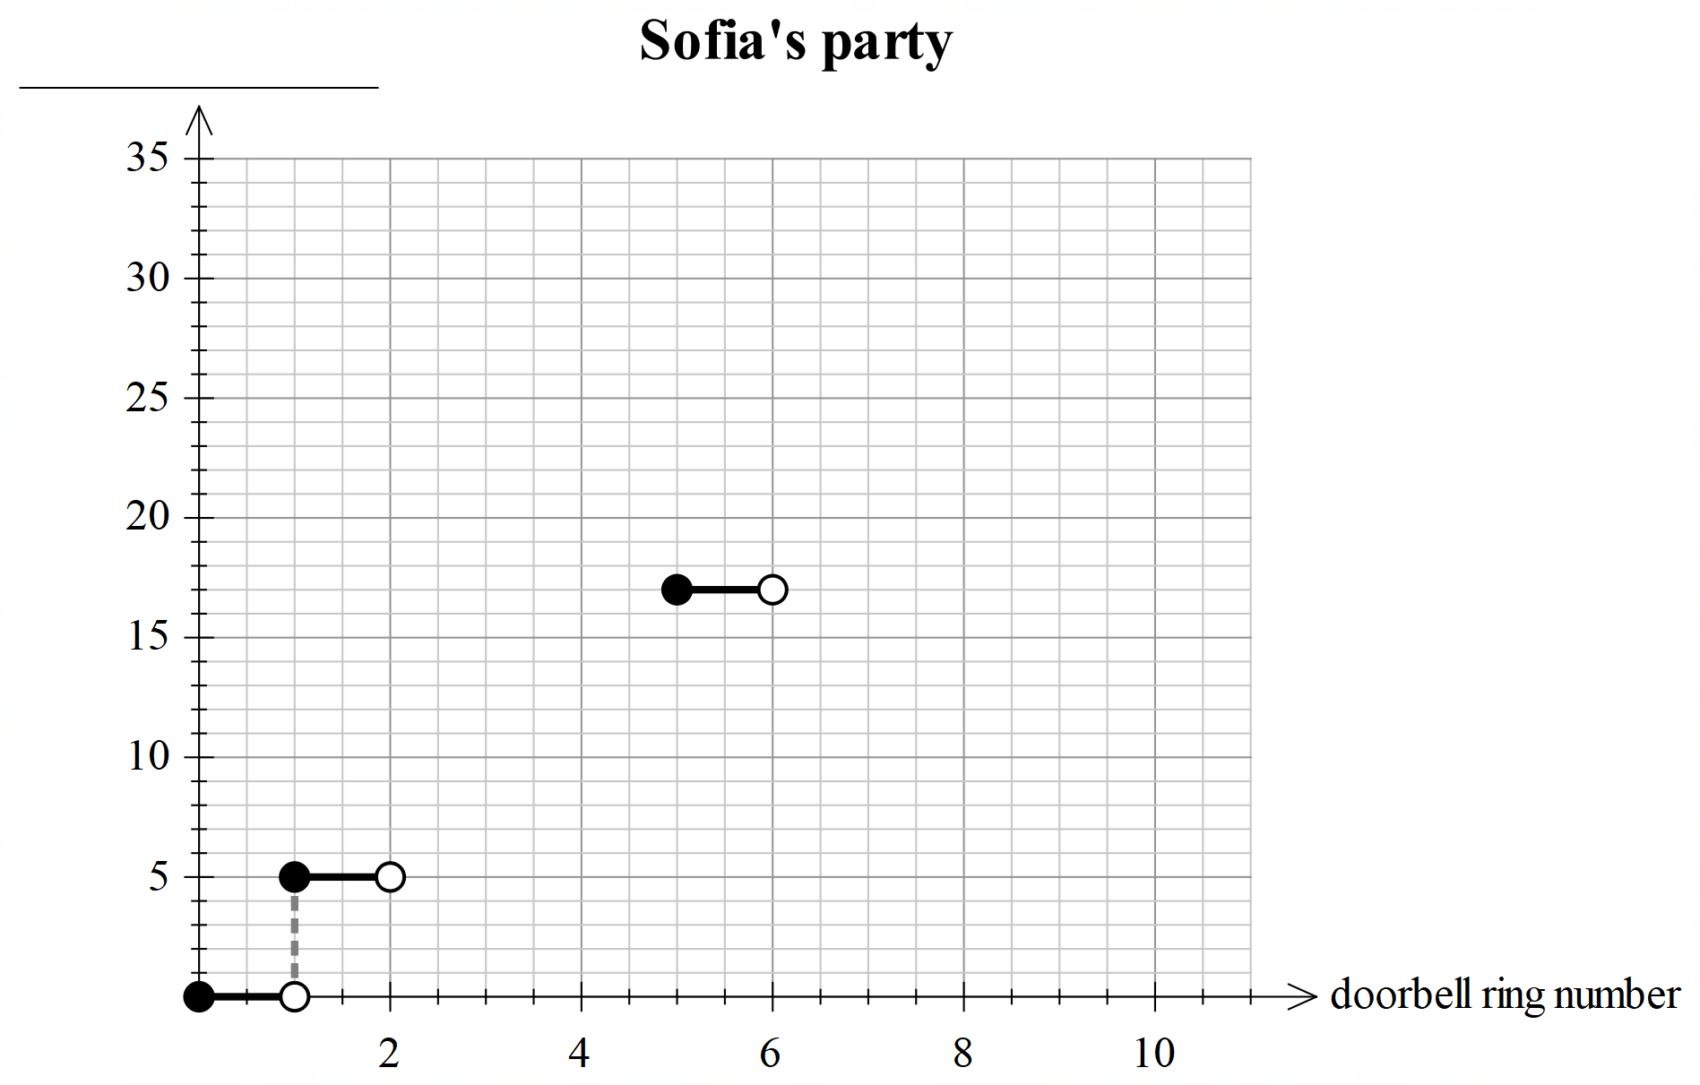

1. State the type of graph you have drawn and explain its main characteristics. (2 marks)
2. State the type of sequence that the number of guests represents. Explain the main characteristics of the sequence and any link these may have with the characteristics of the graph drawn in part (e). (2 marks)
3. Assuming that, no-one left the party early, and you know that there were at least 120 guests at the party, make the most accurate statement possible about the number of times the doorbell must have rung. (2 marks)

**Question 3 (10 marks)**

A country primary school with a population of 350 students and a large metropolitan high school were to implement a Well-Being Program for their students. They first emailed one parent of each child in the school requesting that they answer a question and email their response to the school.

The question was

*Please tick the appropriate box to indicate your level of satisfaction with the pastoral care we offer your child.*

*Not satisfied Fairly satisfied Very satisfied*

The incomplete table below shows the results from the survey. All parents from the primary school responded to the email.

|  |  |  |
| --- | --- | --- |
|  | School A | School B |
| Not satisfied | 50 | 200 |
| Fairly satisfied |  | 250 |
| Very satisfied | 250 | 550 |

(a) Complete the table. (1 mark)

(b) Clearly explain two potential issues with the way the data were collected. (2 marks)

(c) Of those who ticked Not Satisfied, what percentage were from the high school?

(2 marks)

The principal of the primary school sent a follow up email to the same parents. In the email

she stated

“The results to our survey have been analysed. A metropolitan high school conducted the same survey. It is evident from the data obtained that being in a country school causes a much higher level of Very Satisfied parents. Seventy one percent of our parents are Very Satisfied.”

The principal’s claim of 71% of parents from her school being Very Satisfied is correct.

(d) (i) Does the primary school have a higher percentage than the high school of Very Satisfied parents? Justify your response. (3 marks)

(ii) Comment on the principal’s claim that;

*“… being in a country school causes a much higher level of Very Satisfied parents*.”

(2 marks)

**Question 4 (5 marks)**

1. 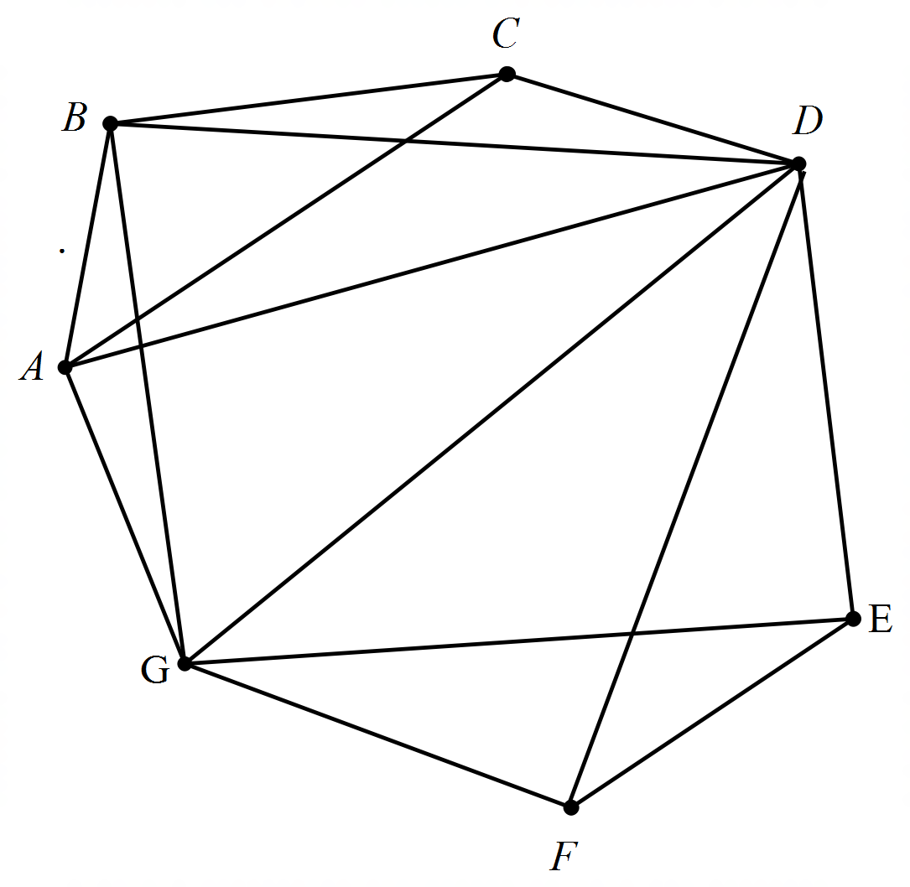Draw a planar version of the network below in which the edges meet only at the vertices. (3 marks)
2. Verify that Euler’s formula works for this network. (2 marks)

**Question 5 (8 marks)**



1. Complete the table below giving the degree of each vertex in the above diagram. (1 mark)

|  |  |  |  |  |  |  |  |
| --- | --- | --- | --- | --- | --- | --- | --- |
| Vertex | A | B | C | D | E | F | G |
| Degree |  |  |  |  |  |  |  |

1. Explain using the table above why the network is neither Eulerian nor Semi-Eulerian (3 marks)
2. The network can be made Eulerian or Semi-Eulerian by removing a single edge. There are three possibilities. Name all three edges and whether the result is Eulerian or Semi-Eulerian. (4 marks)

**Question 6 (8 marks)**

A group of office workers were monitored for their social media usage and response rate to emails in the workday. The following results were obtained from 10 workers.

|  |  |  |  |  |  |  |  |  |  |  |
| --- | --- | --- | --- | --- | --- | --- | --- | --- | --- | --- |
| Time spent on social media (minutes) | 45 | 65 | 25 | 47 | 100 | 35 | 19 | 29 | 12 | 8 |
| Number of emails responded to | 25 | 21 | 42 | 15 | 15 | 55 | 35 | 30 | 60 | 65 |

(a) Complete the graph below for these data. (2 marks)

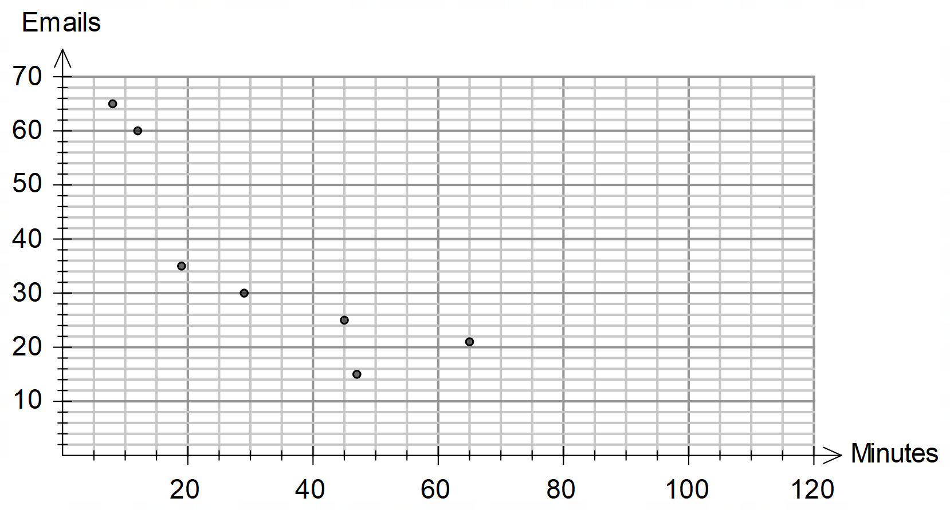

The equation for the least-squares line for predicting the number of emails responded to from

minutes spent on social media is and the correlation coefficient is -0.7663.

(b) Draw the least-squares line on the graph (2 marks)

(c) (i) Use your graph to predict the number of emails responded to by another office

worker who spent 35 minutes on social media. (1 mark)

(ii) Comment on the reliability of your prediction. (2 marks)

Workers who spent more than 45 minutes on social media were considered ineffective and

asked to resign their jobs.

(d) With the removal of the data representing ineffective workers, describe what would happen to the slope of the least-squares line. (1 mark)

**End of Questions**

Additional working space

Question number: __________________

Additional working space

Question number: __________________

© MAWA, 2020

This examination is Copyright but may be freely used within the school that purchases this licence.

* The items that are contained in this examination are to be used solely in the school for which they are purchased.
* They are not to be shared in any manner with a school which has not purchased their own licence.
* The items and the solutions/marking keys are to be kept confidentially and not copied or made available to anyone who is not a teacher at the school. Teachers may give feedback to students in the form of showing them how the work is marked but students are not to retain a copy of the paper or marking guide until the agreed release date stipulated in the purchasing agreement/licence.

*Published by The Mathematical Association of WA*

*12 Cobbler Place, MIRRABOOKA 6061*